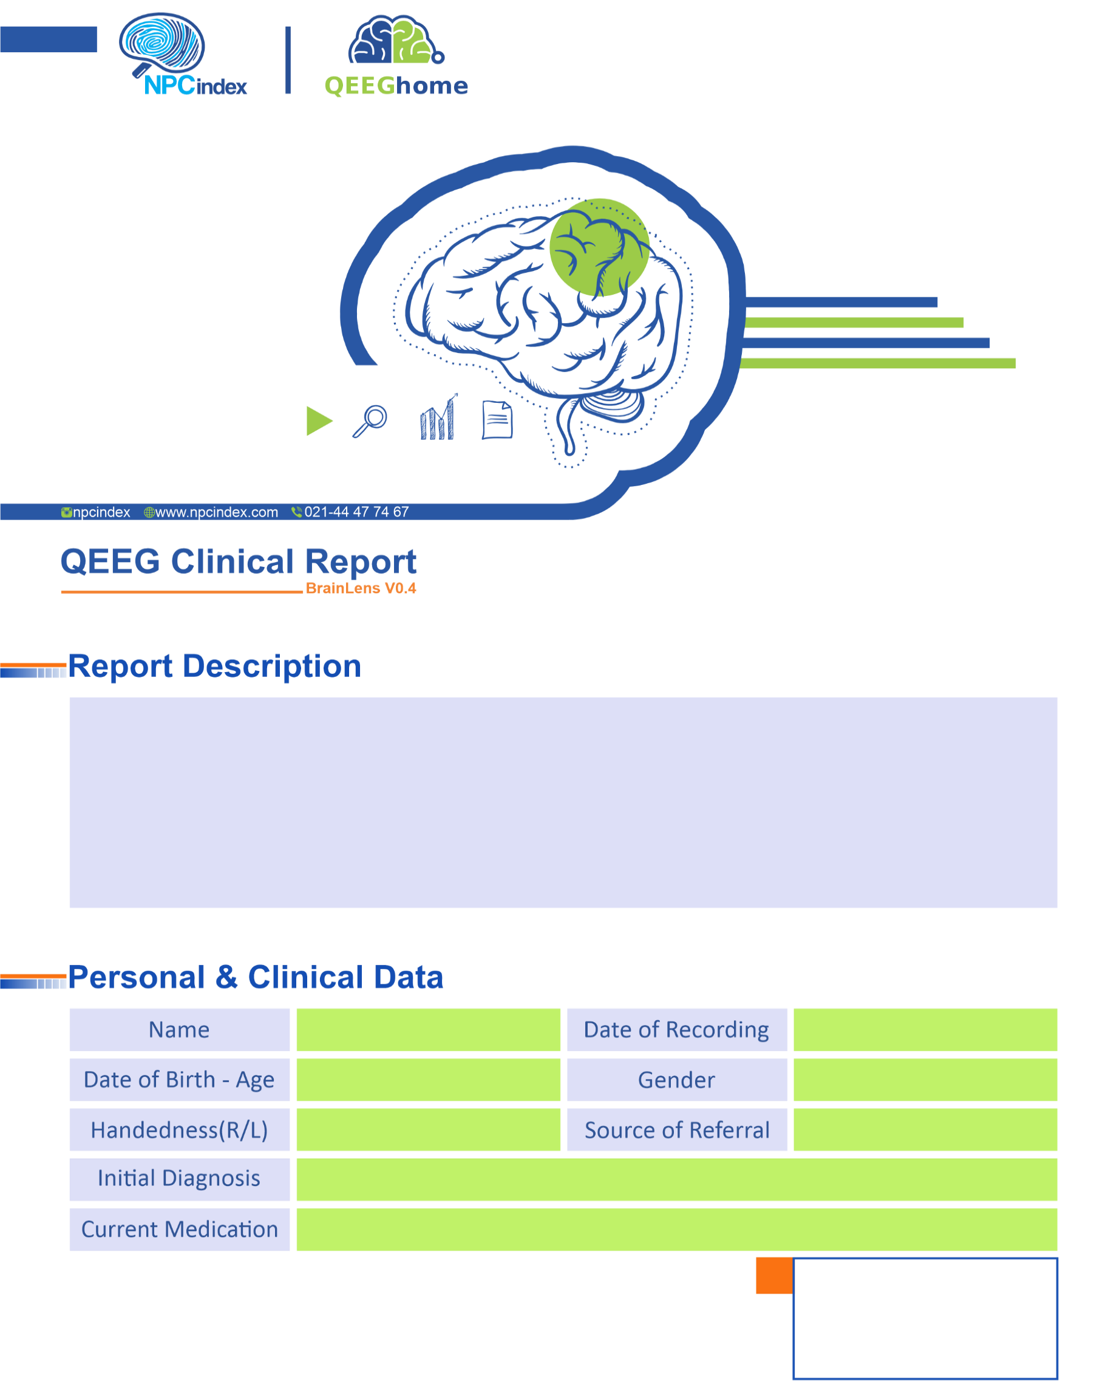
Asayesh Psychiatric Clinic - Dr Torabi
Asayesh Psychiatric Clinic - Dr Torabi
Male
21-Jan-2025
-
Anxiety-HTN-Irritability-PIC
Right
22-Apr-1986 - 38.75
Behnazm Razavi

