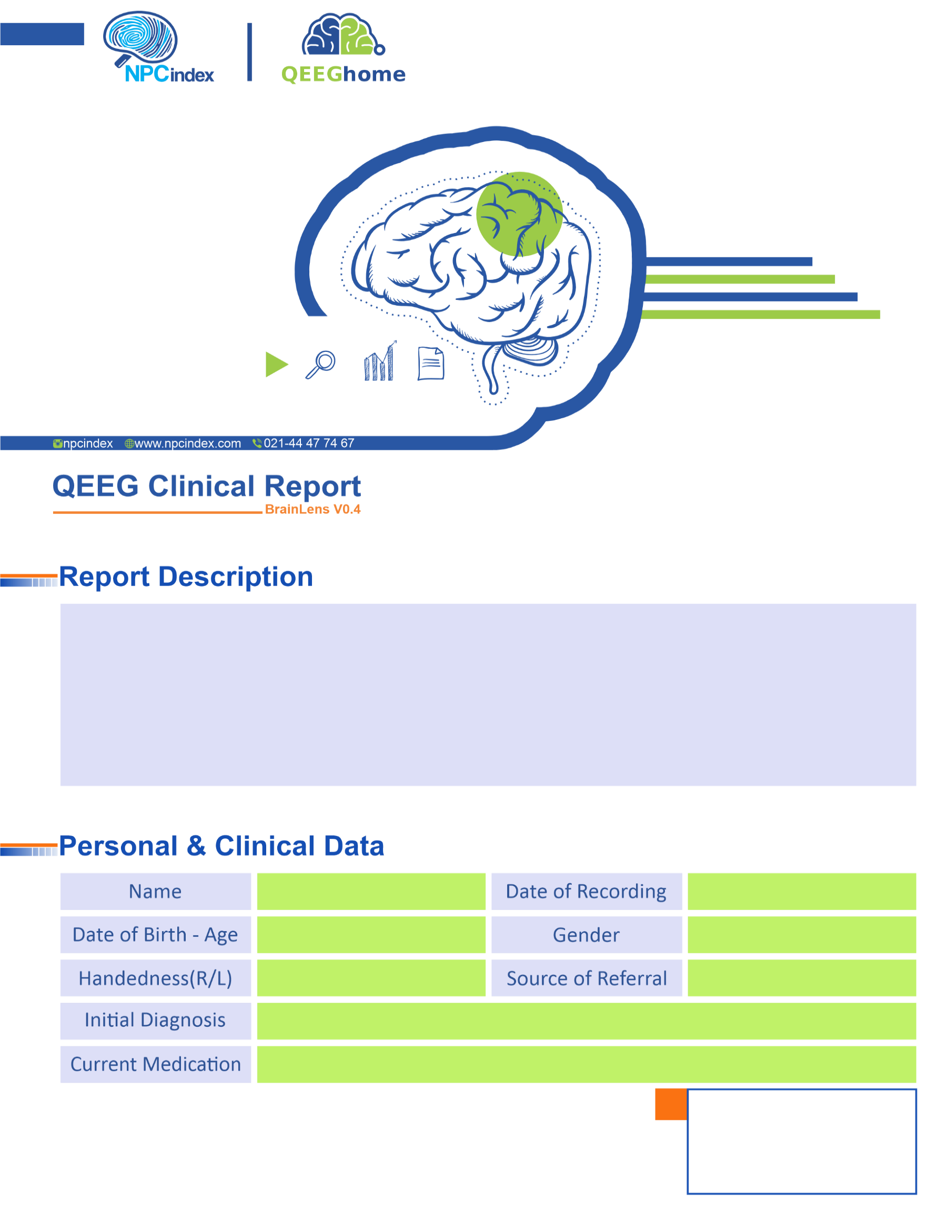
Asayesh Psychiatric Clinic - Dr Torabi
Asayesh Psychiatric Clinic - Dr Torabi
Male
03-Feb-2025
Clonidine-Fluoxetine-Lithium Carbonate-Vyas
OCD-Puberty-R/O ADHD
Right
20-Nov-2006 - 18.2
Mohammadmahdi Roshanaei

