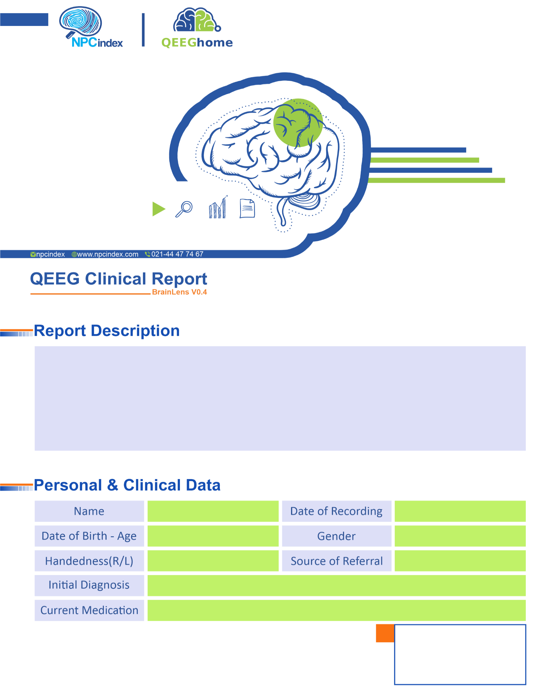
Asayesh Psychiatric Clinic - Dr Torabi
Asayesh Psychiatric Clinic - Dr Torabi
Male
03-Feb-2025
-
ADHD-L.D
Right
01-Sep-2018 - 5.42
Amirali Babei

