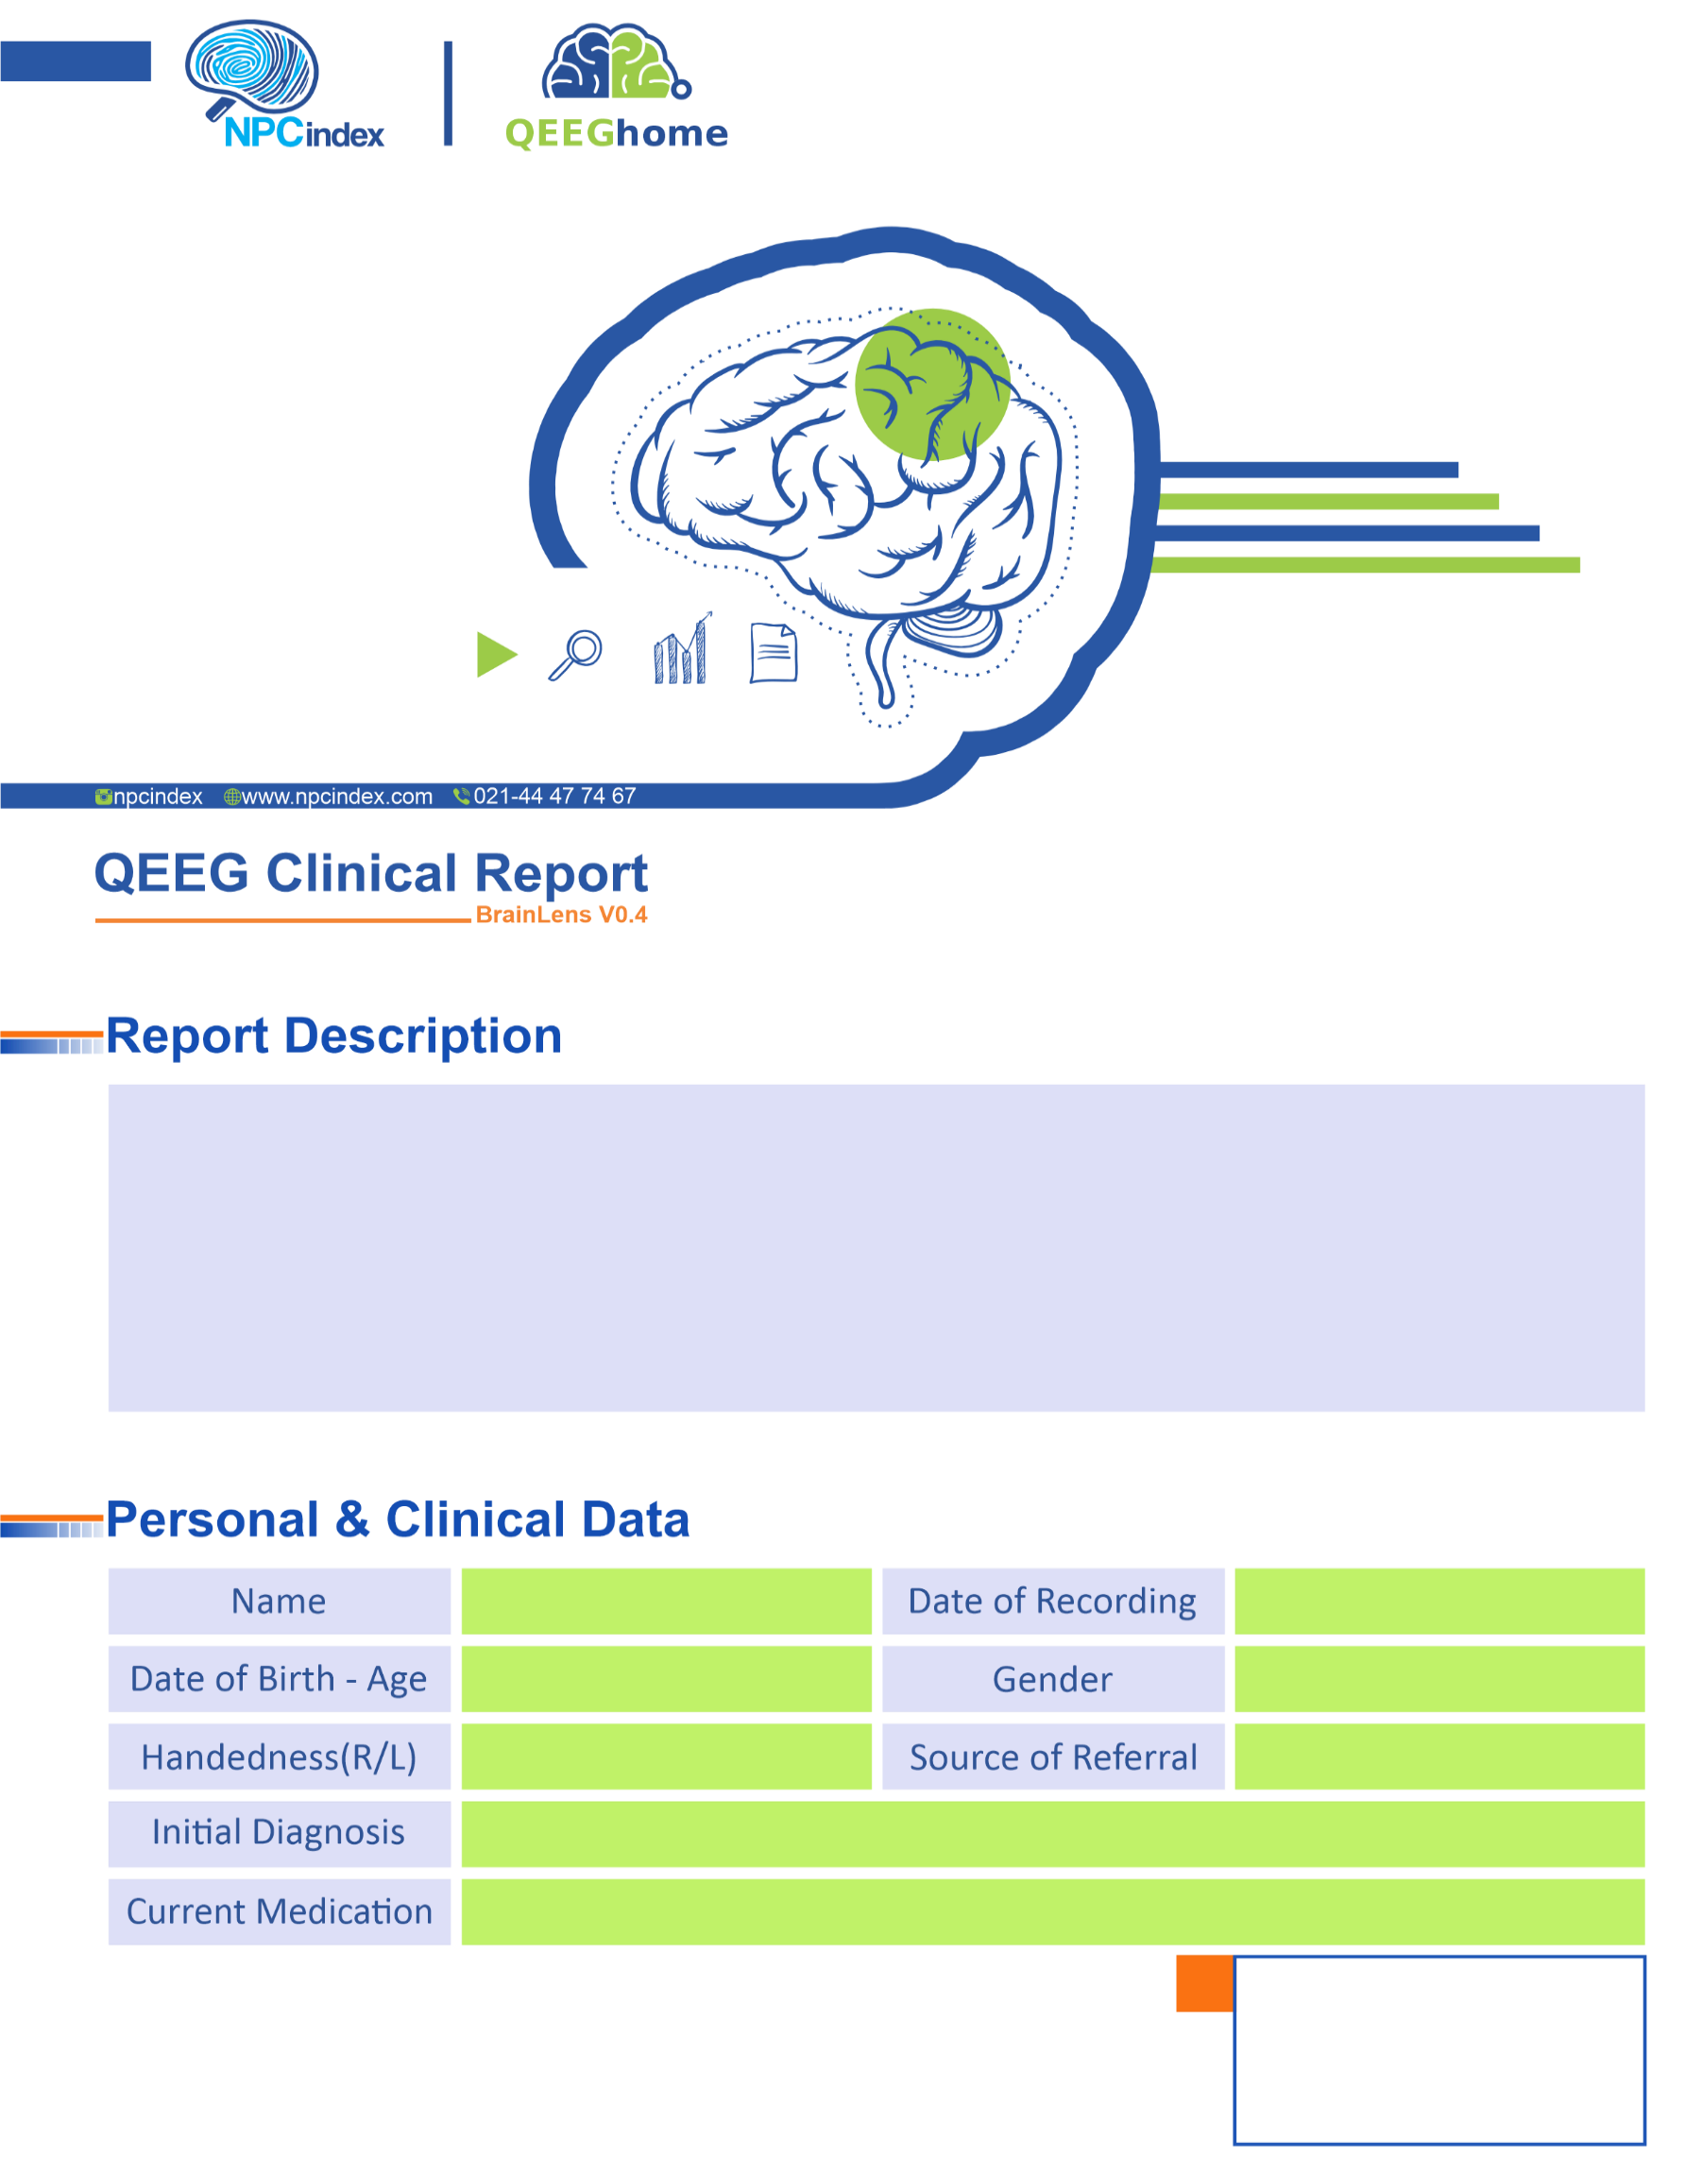
Asayesh Psychiatric Clinic - Dr Torabi
Asayesh Psychiatric Clinic - Dr Torabi
Female
09-Feb-2025
Fluoxetine
Anxiety-P.P.P-TRD
Right
17-Dec-1990 - 34.15
Roghayye Mohammadalipour

