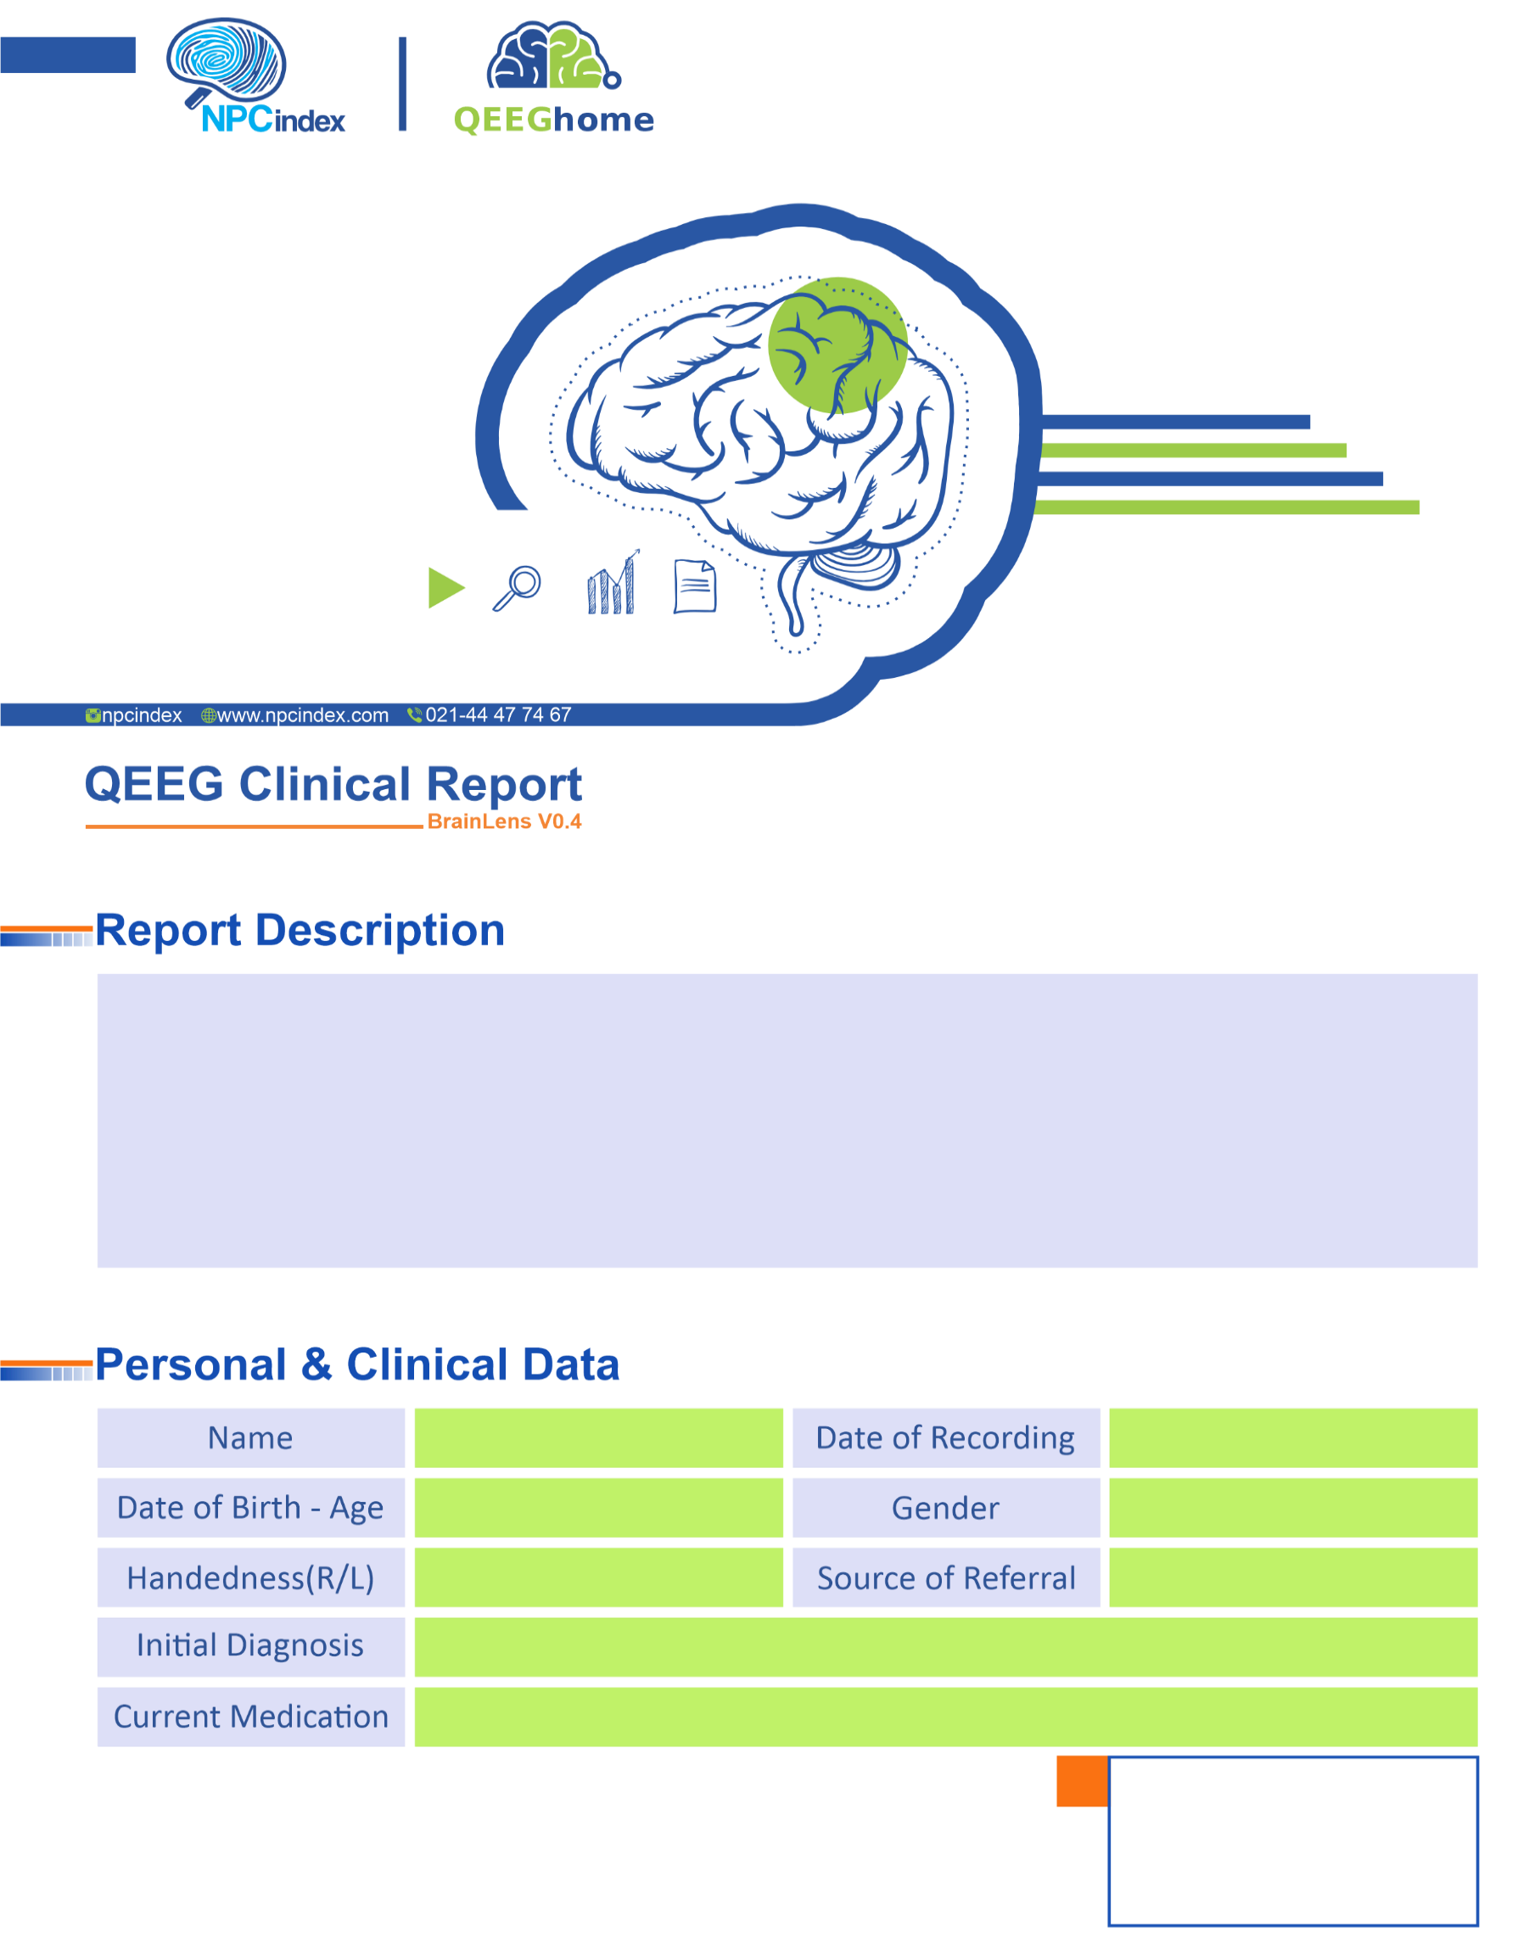
Asayesh Psychiatric Clinic - Dr Torabi
Asayesh Psychiatric Clinic - Dr Torabi
Male
25-Feb-2025
-
ADHD-Anxiety-TIC
Right
2016-11-25 - 8.25
Nikan Rezaei

