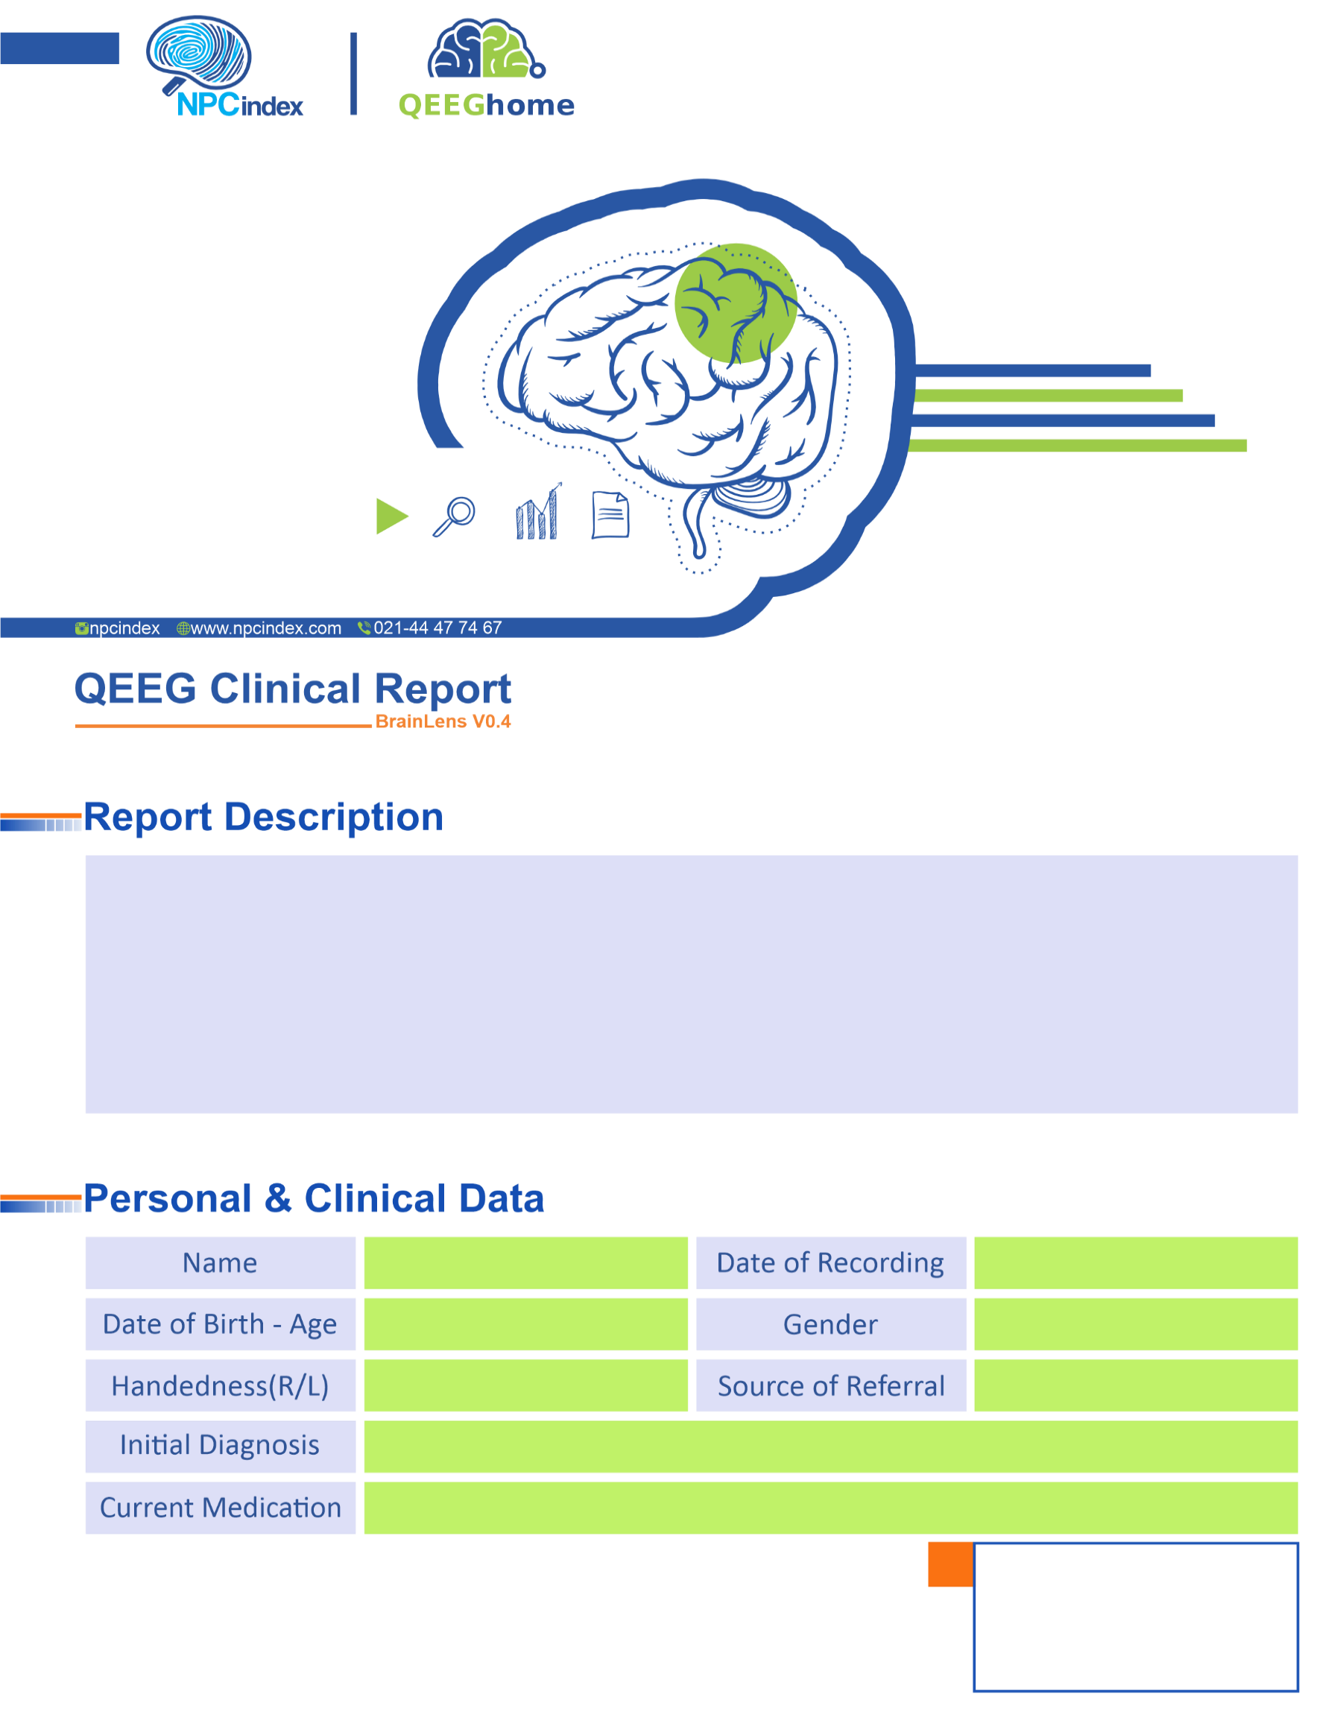
Asayesh Psychiatric Clinic - Dr Torabi
Asayesh Psychiatric Clinic - Dr Torabi
Male
2025-06-22
-
Anxiety-Divorced Parents-IBS-Irritability
Left
2015-10-22 - 9.67
Fateme Roshanei

