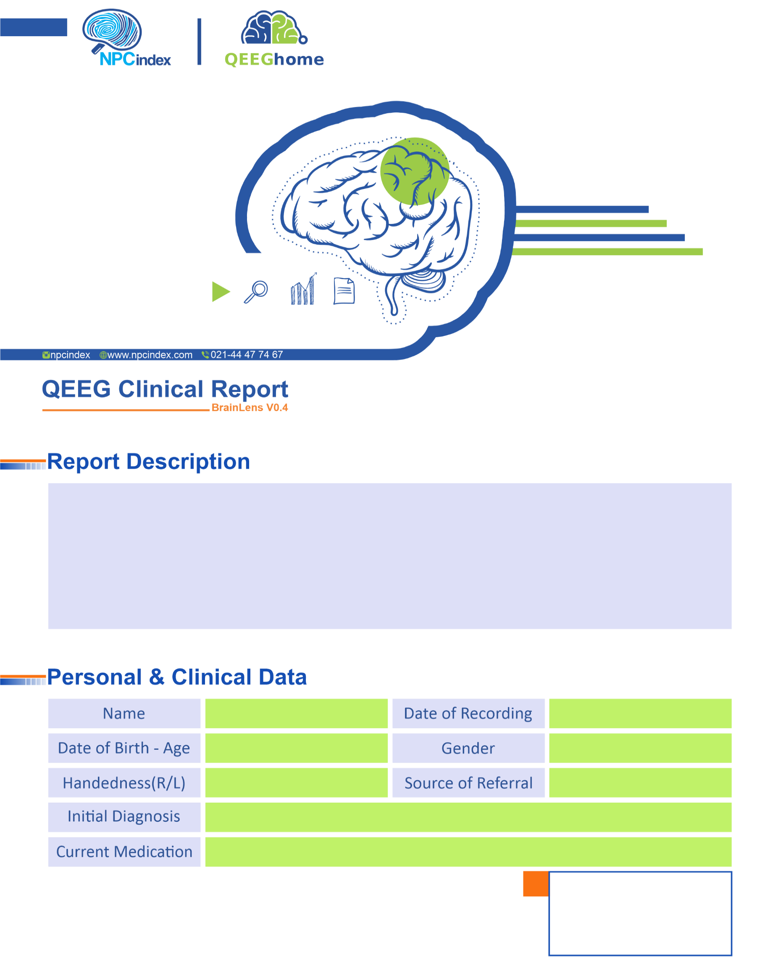
Asayesh Psychiatric Clinic - Dr Torabi
Asayesh Psychiatric Clinic - Dr Torabi
Female
2025-06-24
Alventa-Lamotrigine-Losartan-Quetiapine
Dysthymia-HTN-Post CVA-TIA
Left
1957-12-01 - 67.7
Masoume Afsouni

