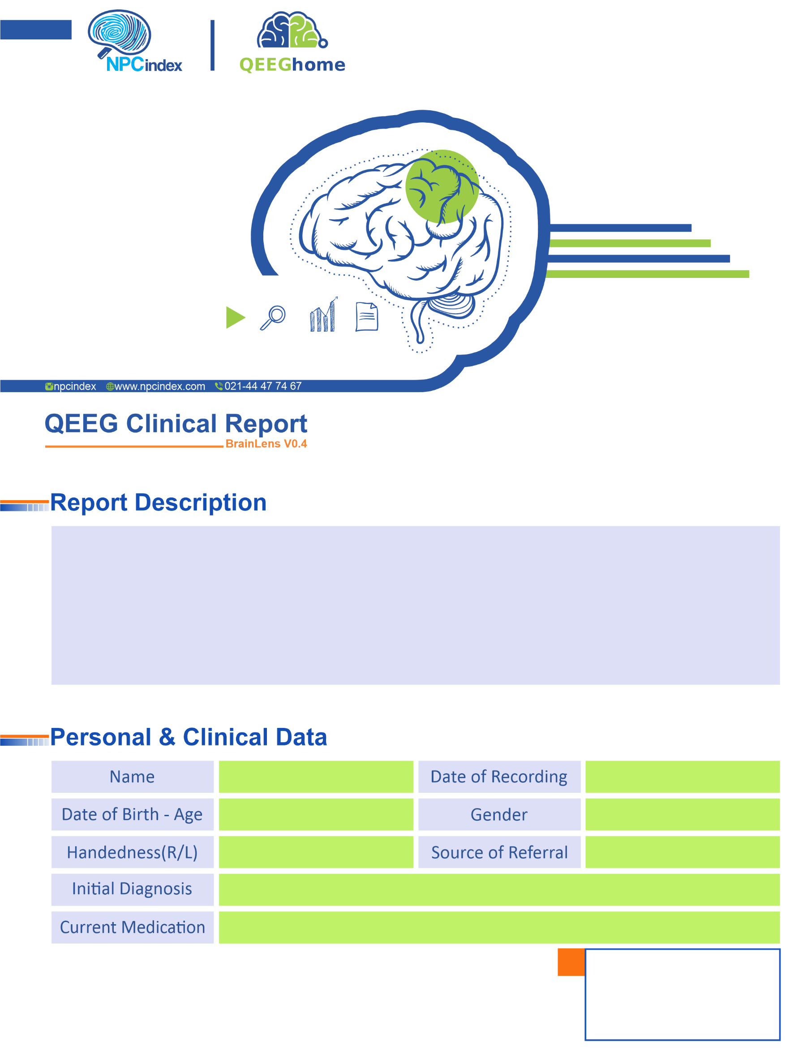

Dr Saemi
-
Dr Saemi
Male
06-Dec-2023
Adult ADHD- LOW MOOD -IMPULSIVITY-UNCONTOROL-AGGRESIVE
Right
22-Nov-1991 - 32.04
Pourya Jaryan

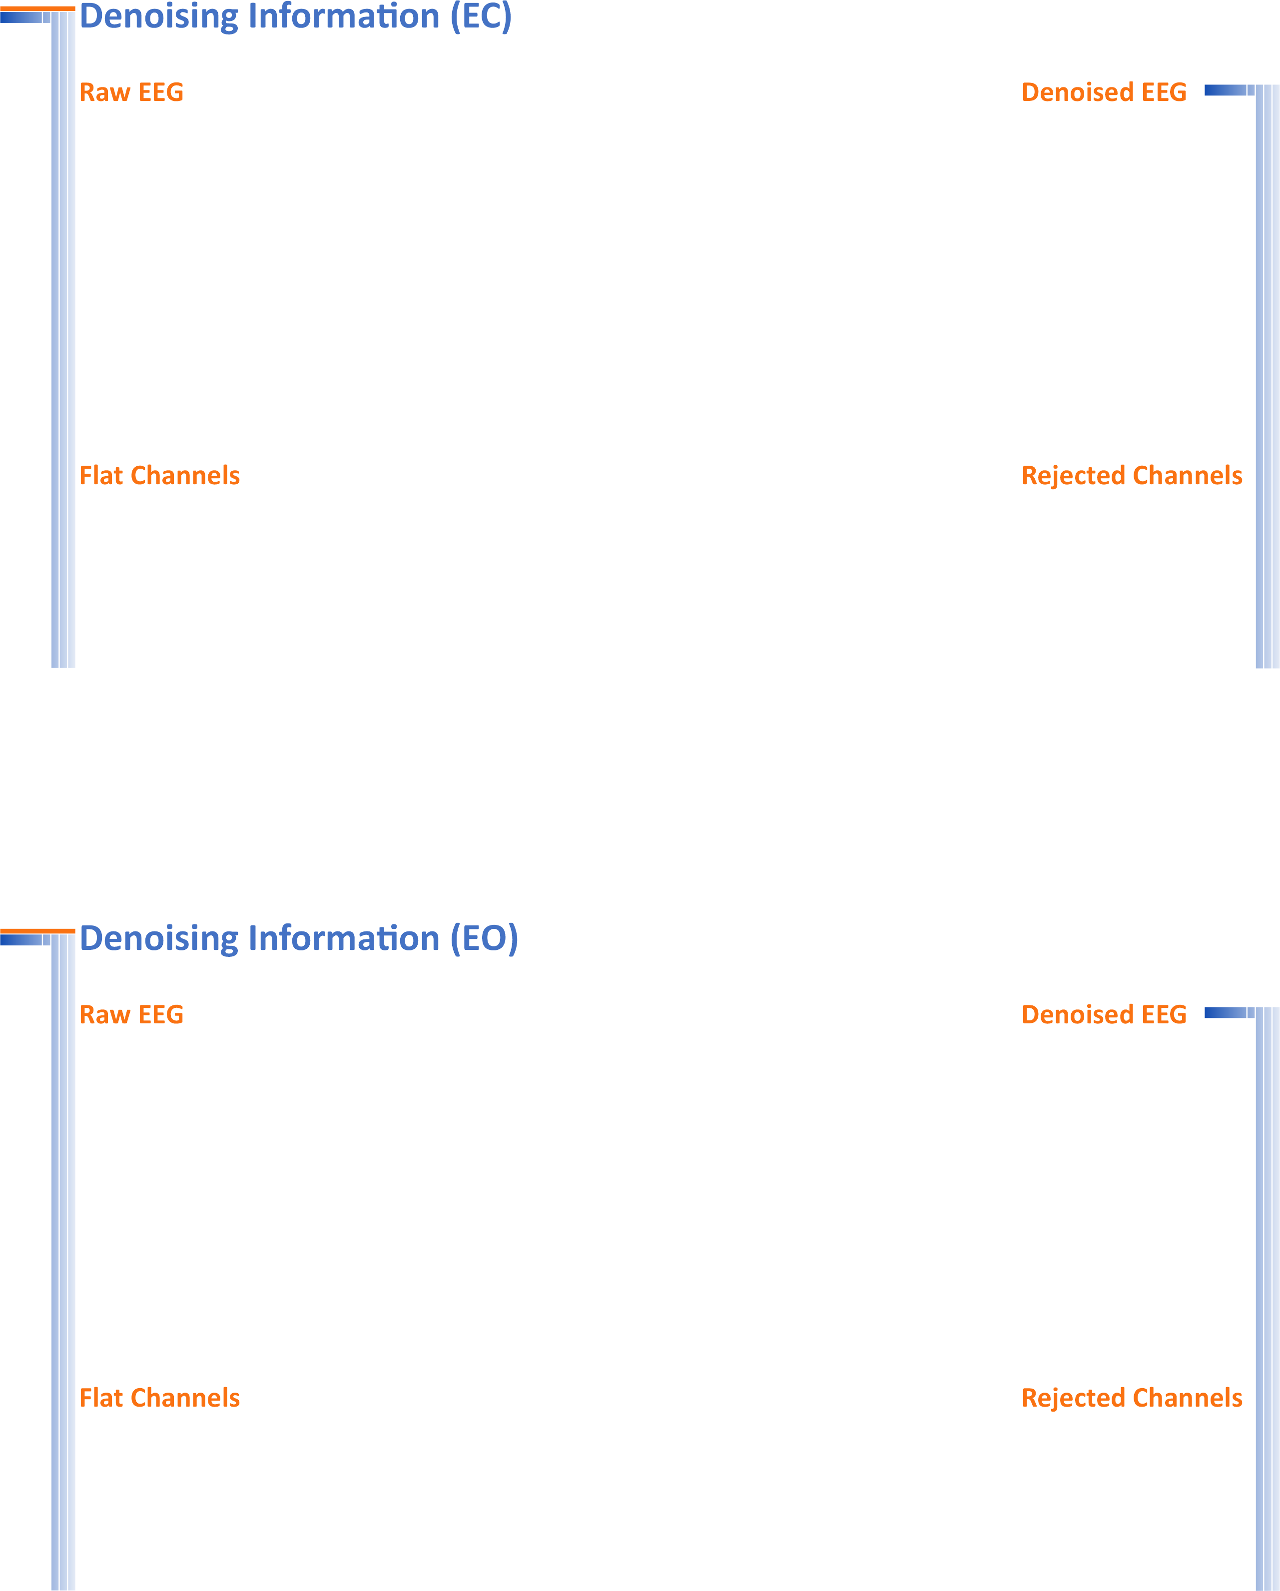
Number of Eye and Muscle Elements |  |  |  | Low Artifact Percentage
Eye | 0 | Muscle | 0
Total Artifact Percentage |  |  |  | High Artifact Percentage
EEG Quality |  | bad |  | Total Recording Time Remaining | 308.55 sec

Number of Eye and Muscle Elements |  |  |  | Low Artifact Percentage
Eye | 0 | Muscle | 0
Total Artifact Percentage |  |  |  | High Artifact Percentage
EEG Quality |  | bad |  | Total Recording Time Remaining | 296.50 sec

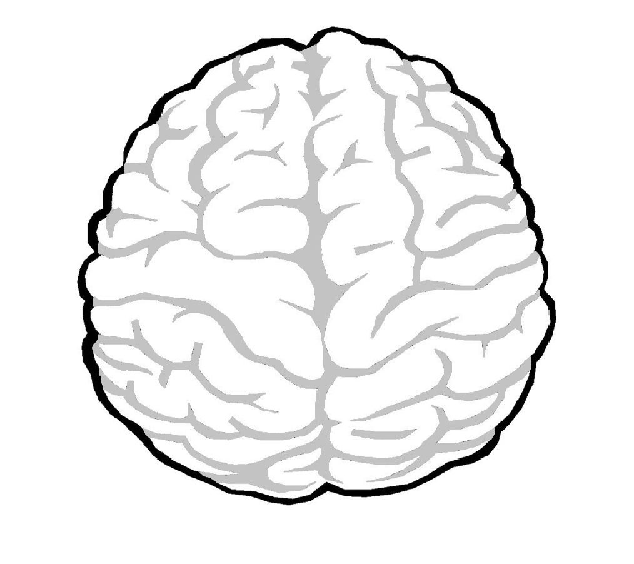

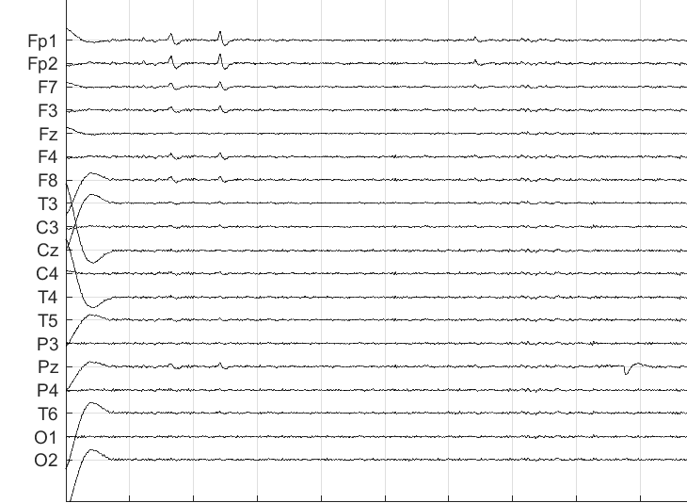 | 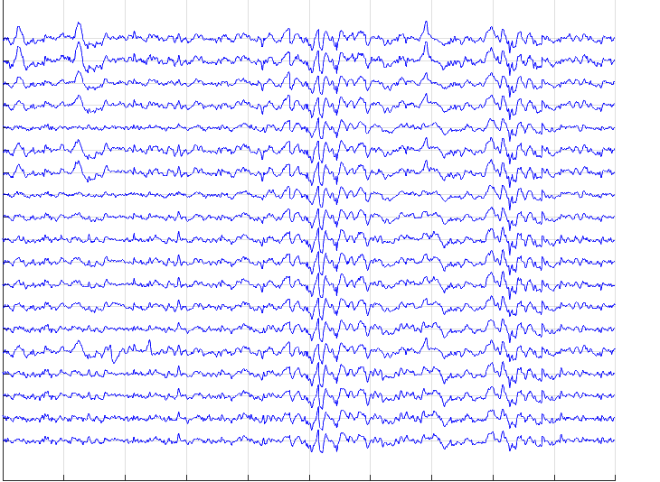

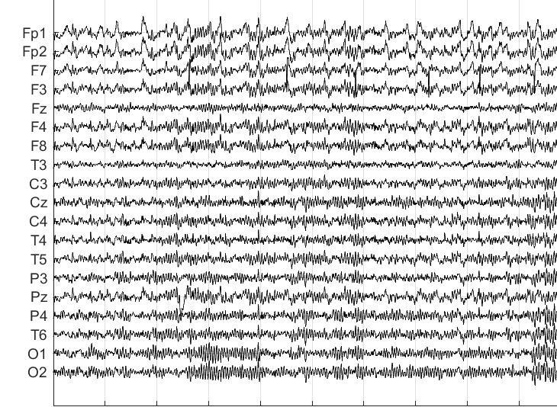 | 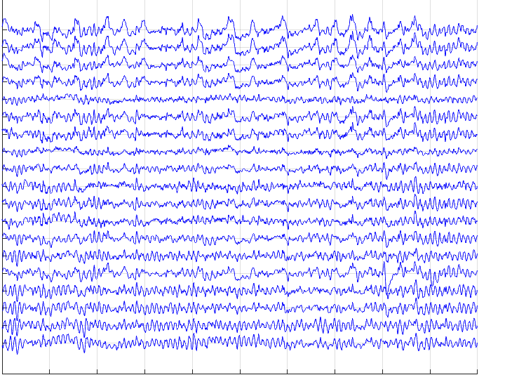

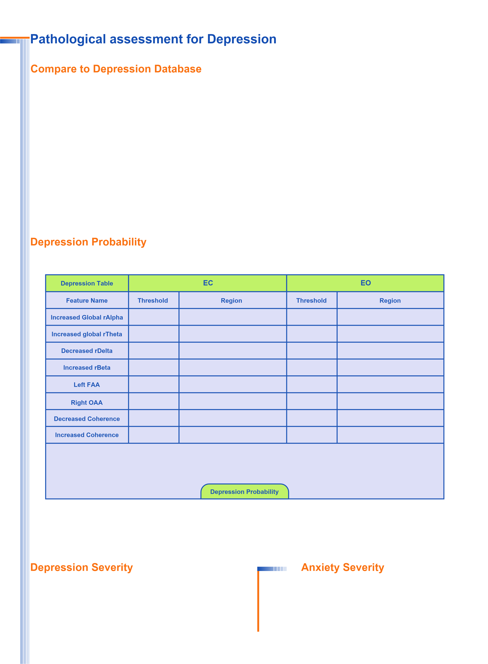
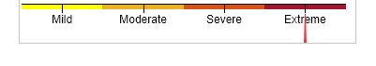
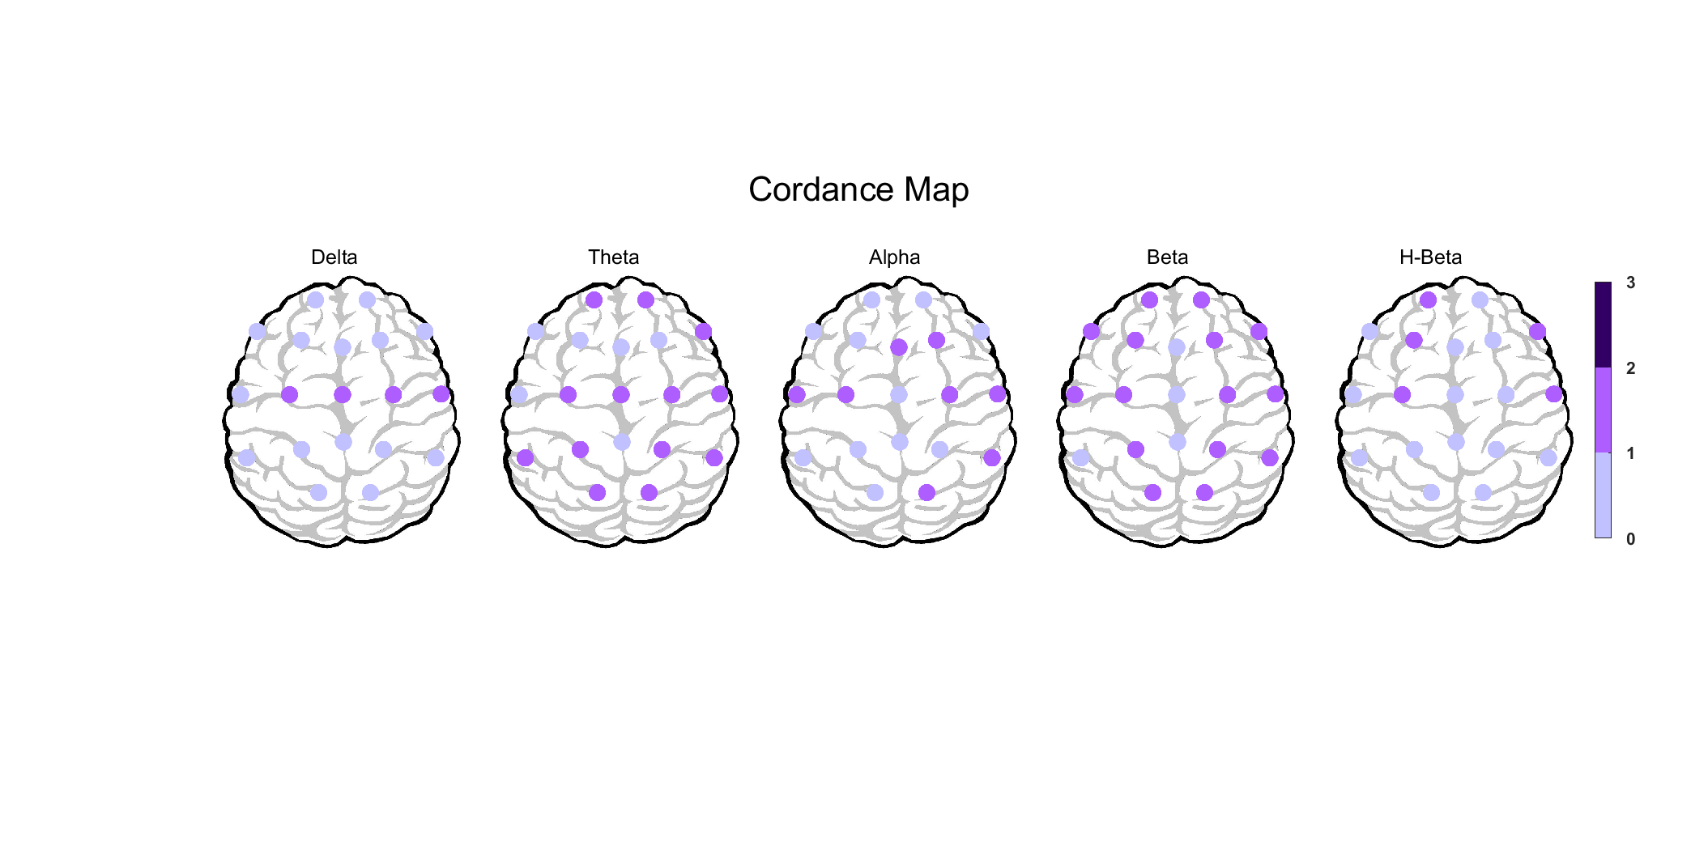
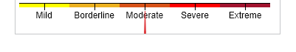
Decreased Coherence (A,B)

Decreased Coherence (D,T)

NAN

Left FAA

NAN

NAN

global

3.00

-0.50

0.00

-0.12

0.00

0.00

1.00

Decreased Coherence (A,B)

Decreased Coherence (D,T)

NAN

Left FAA

NAN

NAN

O
0
-0.12

3.00

-0.50

0.00

0.00

-0.50

0.00

NAN

0.00

global

0.50

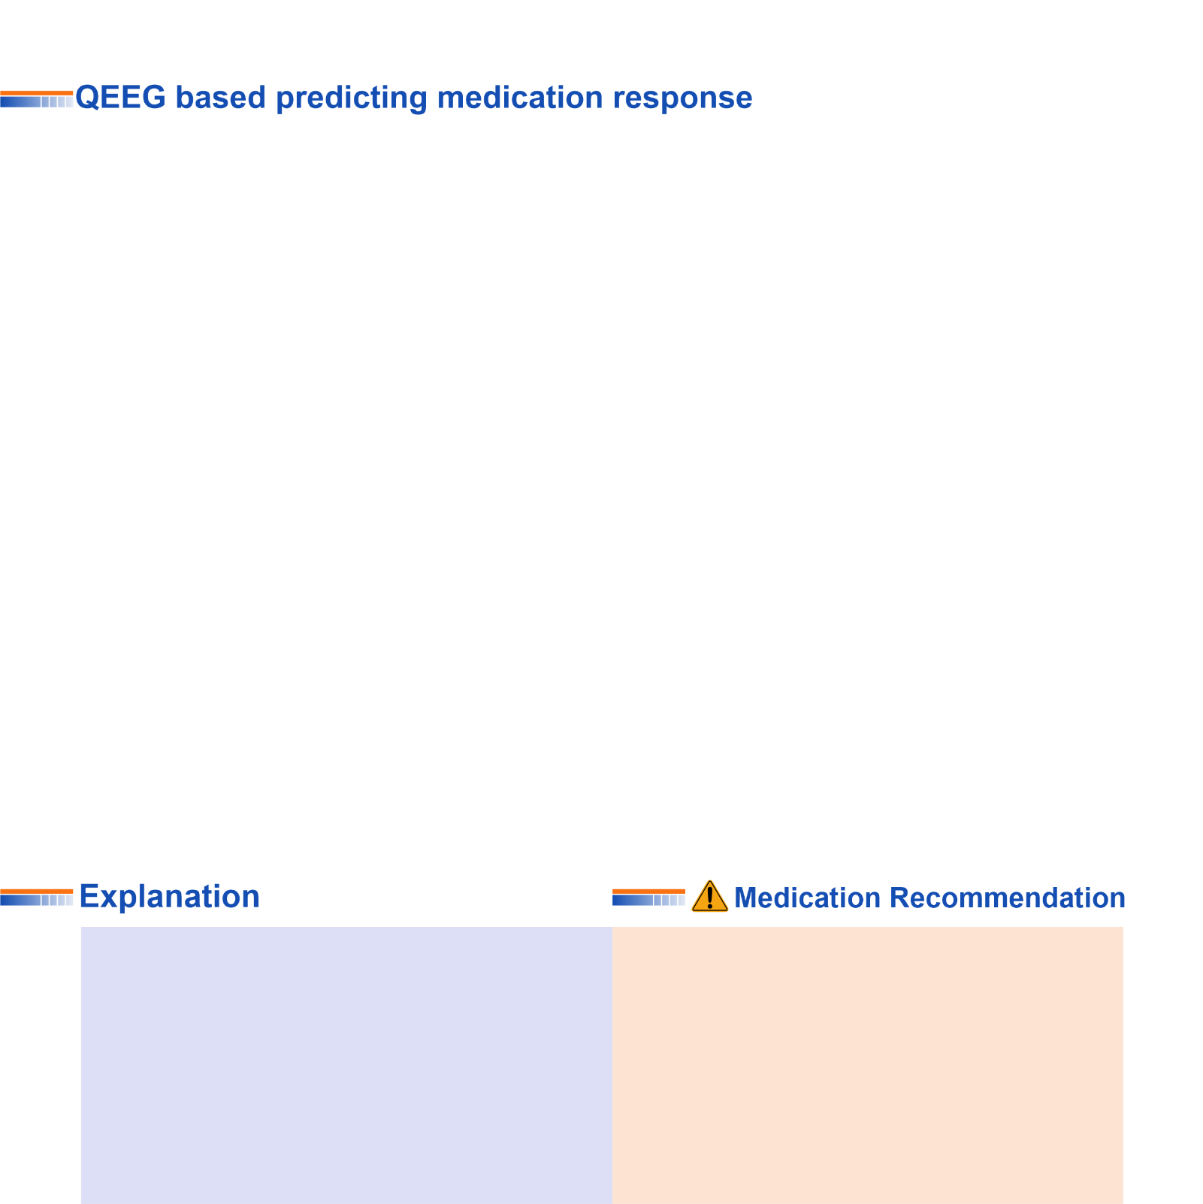
These two charts, calculate response probability to various medications, according only to QEEG indicators. Blue charts favor drug response and red charts favor drug resistance. The longer the bar, the more evidence there is in the articles. Only drugs listed in the articles are listed. These tables present the indicators reviewed in the QEEG studies and are not a substitute for physician selection.

These two tables can be considered the most important finding that can be extracted from QEEG. To prepare this list, the NPCIndex Article Review Team has studied, categorized, and extracted algorithms from many authoritative published articles on predict medication response and Pharmaco EEG studies. These articles are published between 1970 and 2021. The findings extracted from this set include 85 different factors in the raw band domains, spectrum, power, coherence, and loreta that have not been segregated to avoid complexity, and their results are shown in these diagrams. One can review details in NPCIndex.com .

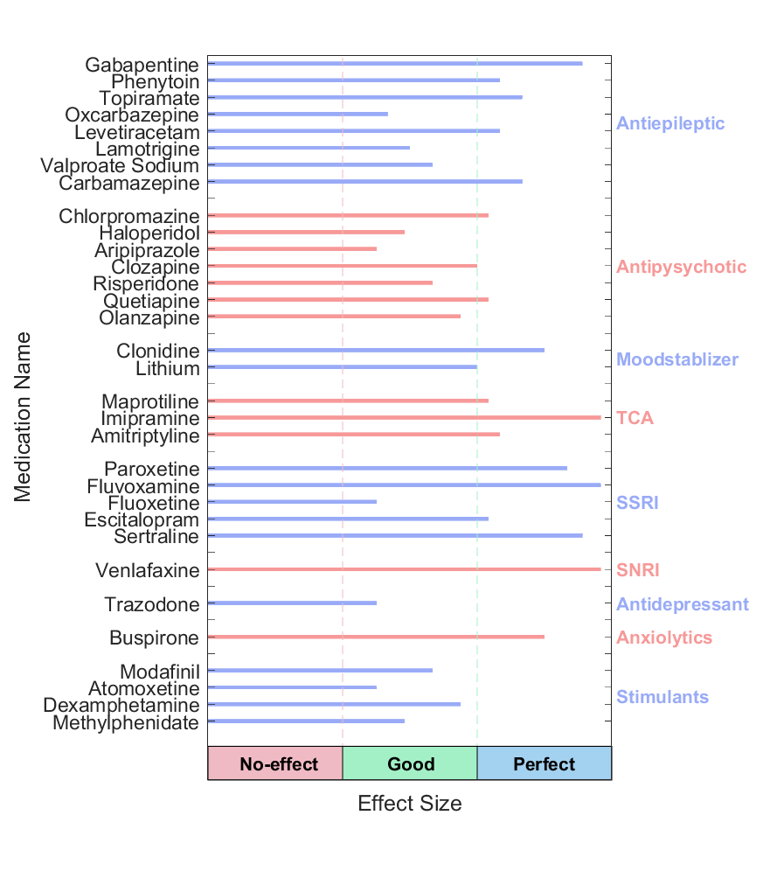

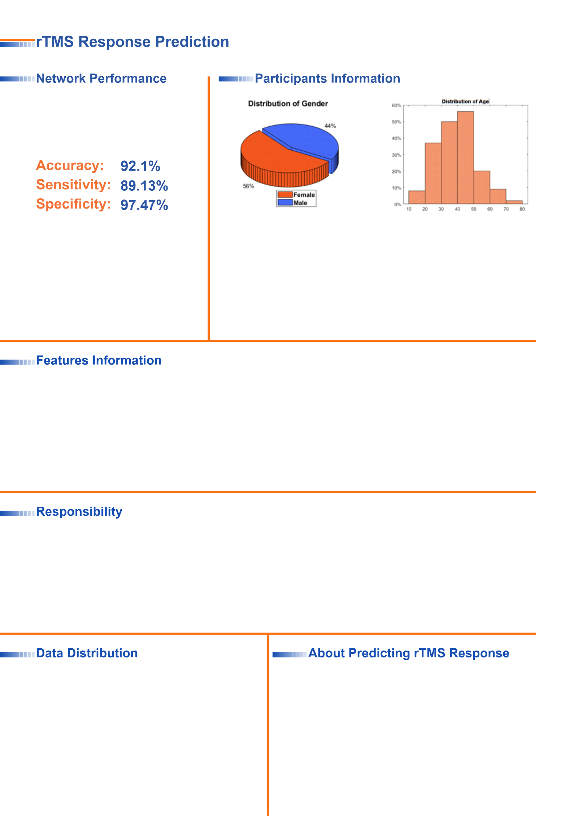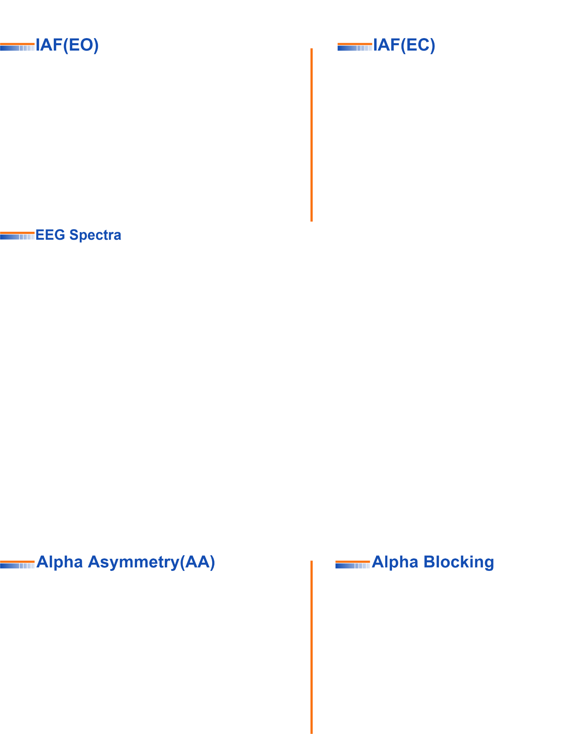
This index was obtained based on machine learning approaches and by examining the QEEG biomarkers of more than 470 cases treated with rTMS. The cases were diagnosed with depression (with and without comorbidity) and all were medication free. By examining more than 40 biomarkers capable of predicting response to rTMS treatment in previous studies and with data analysis, finally 10 biomarkers including bispectral and nonlinear features entered the machine learning process. The final chart can distinguish between RTMS responsive and resistant cases with 92.1% accuracy. This difference rate is much higher than the average response to treatment of 44%, in the selection of patients with clinical criteria, and is an important finding in the direction of personalized treatment for rTMS.

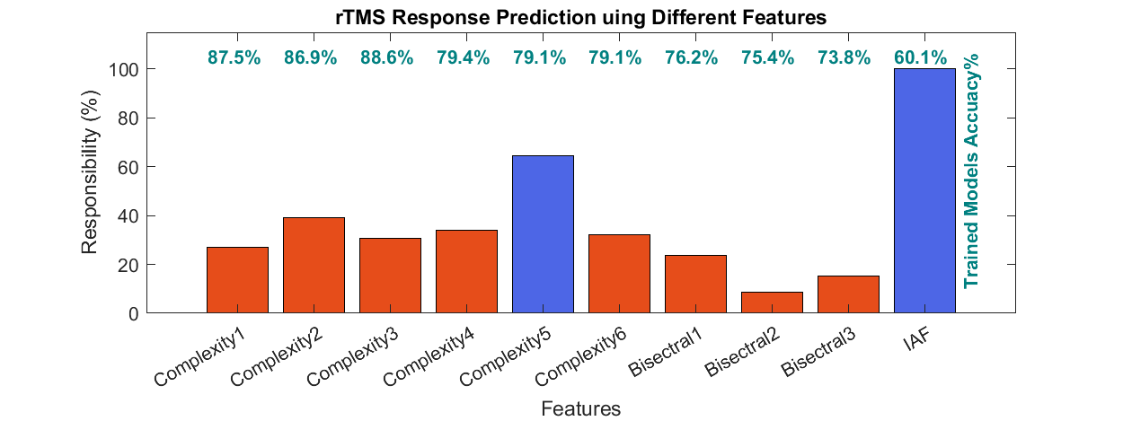

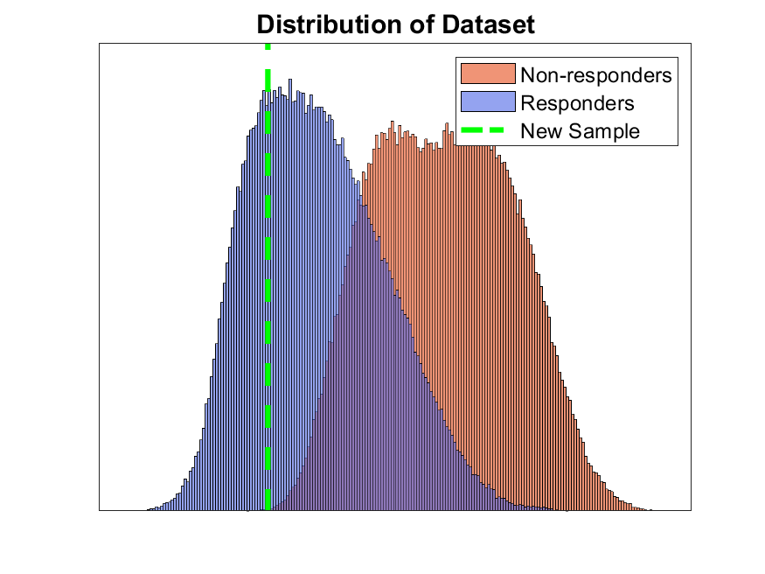

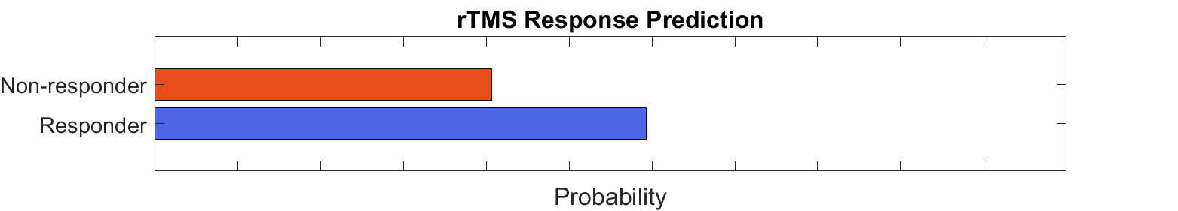

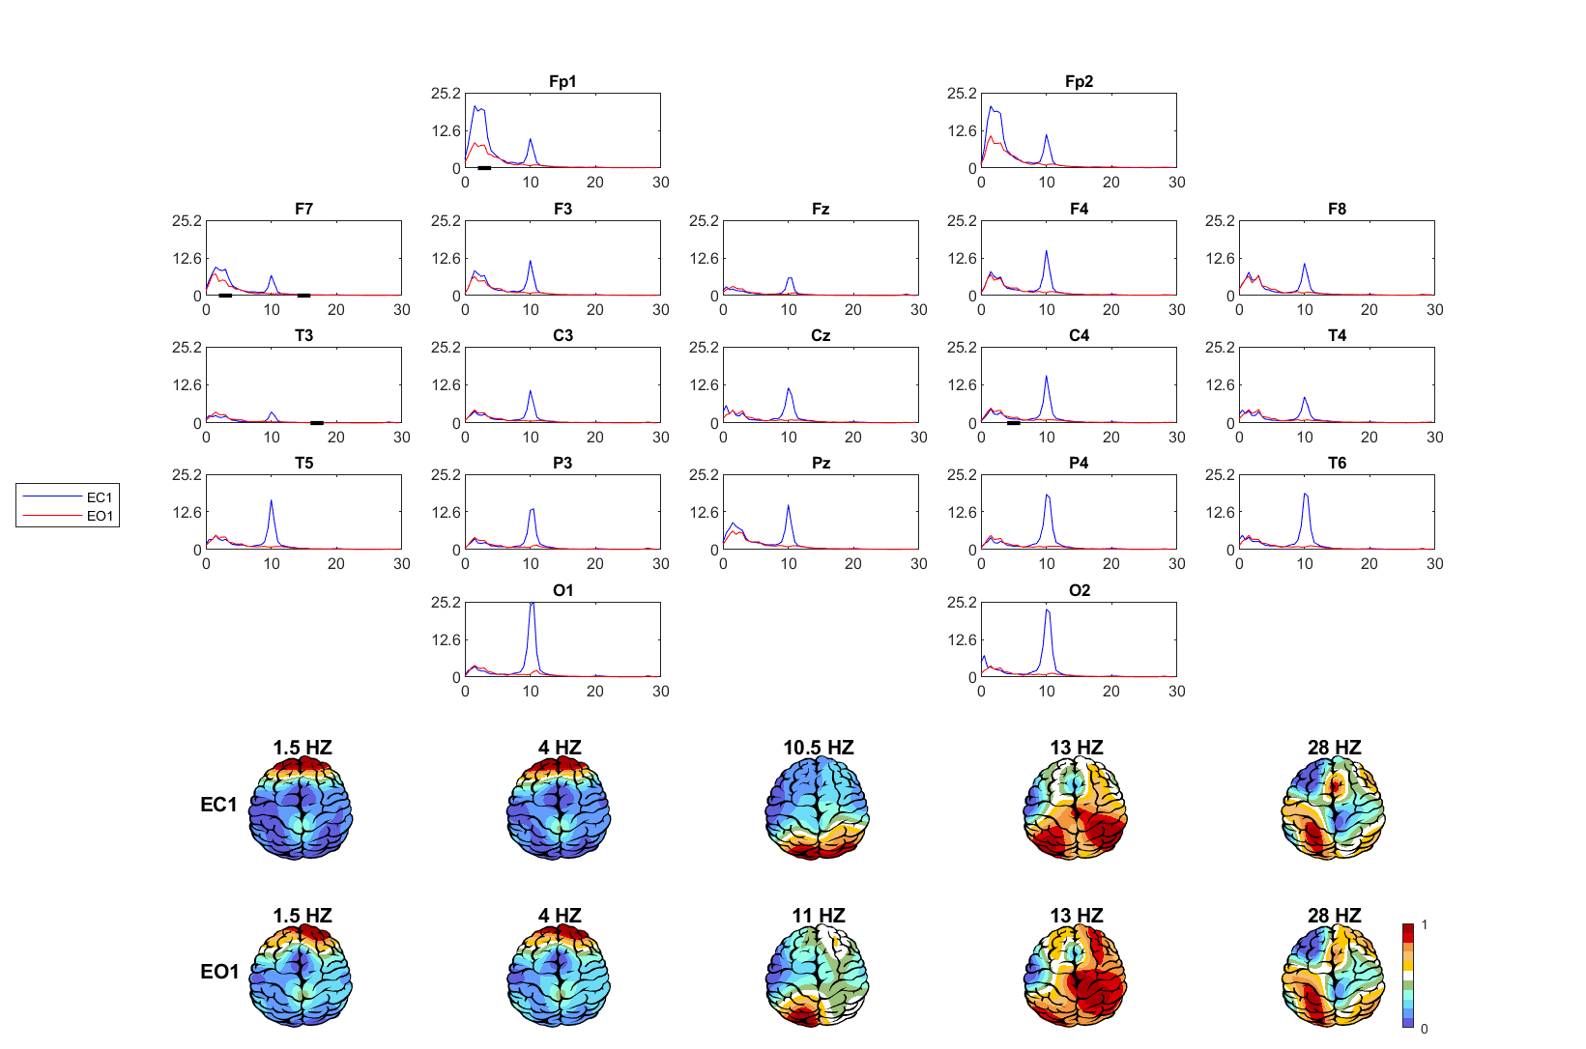
Eye Open IAF= 10.75
Eye Close IAF= 10.25


