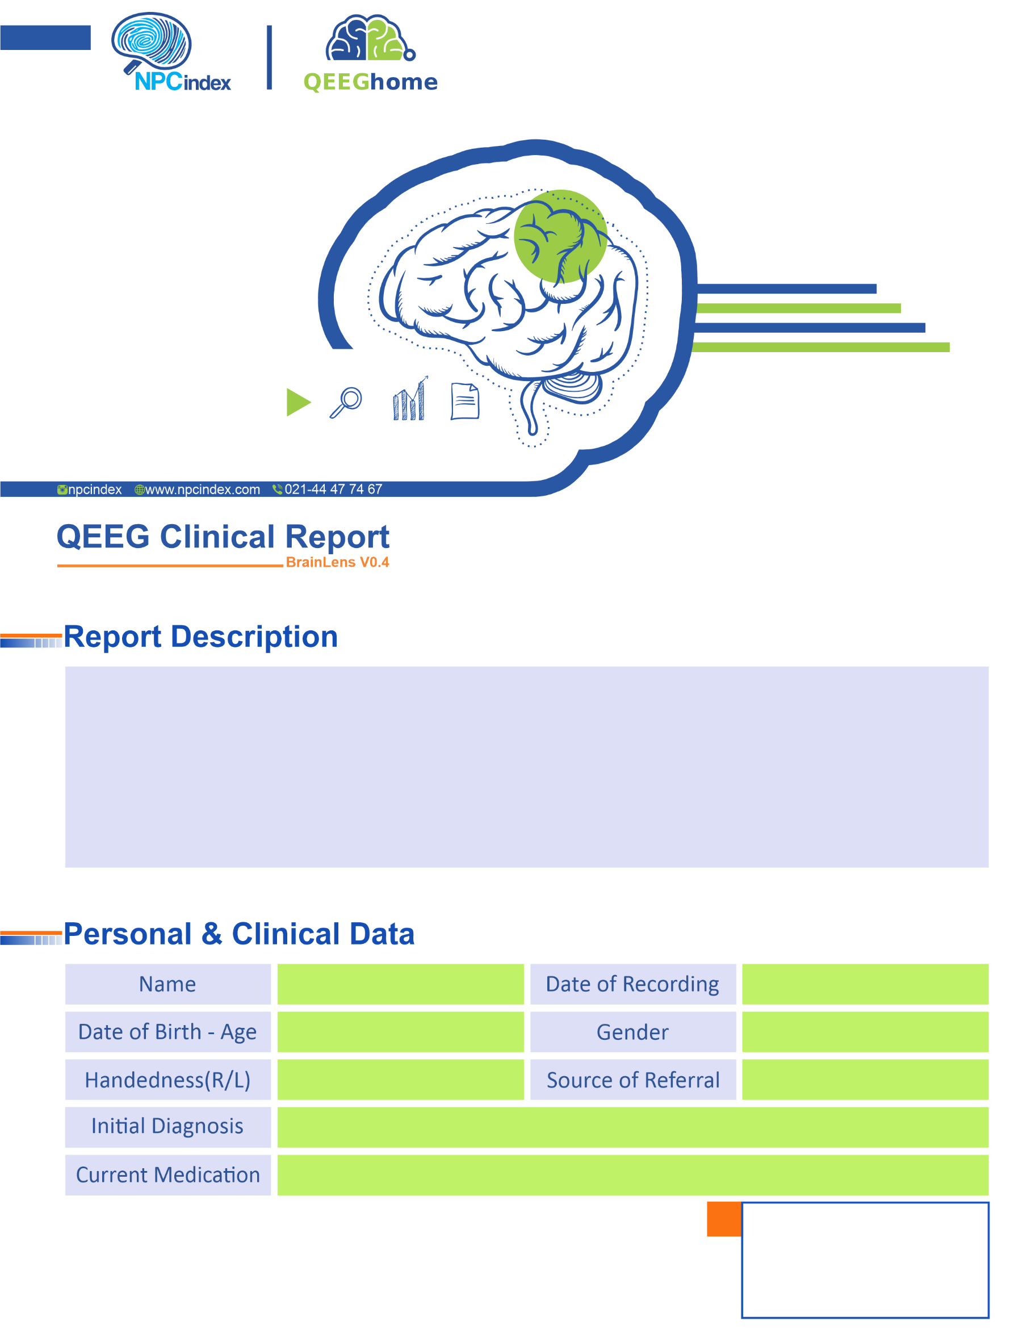

Dr Masjedi
Medication Free
Dr Masjedi
Female
30-Jun-2024
PTSD-Phobia-Anxiety
Right
21-Mar-1978 - 46.27
Zahra Alemirad
Text
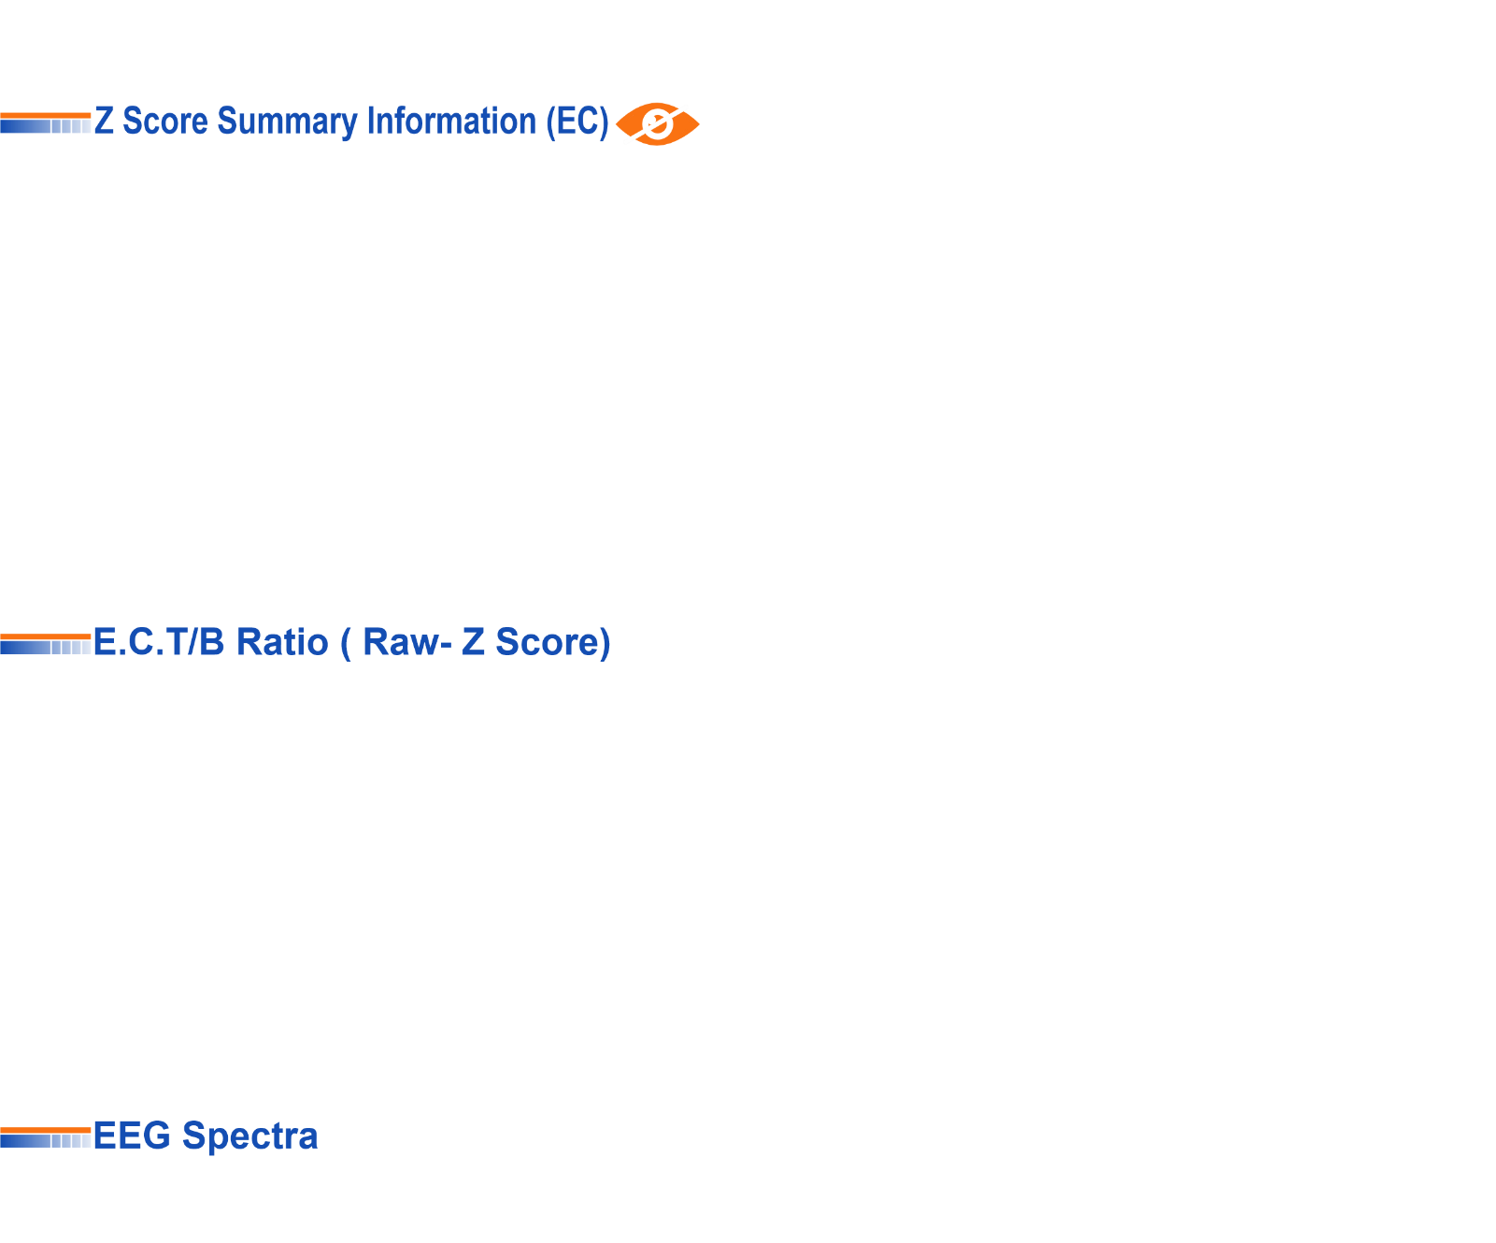

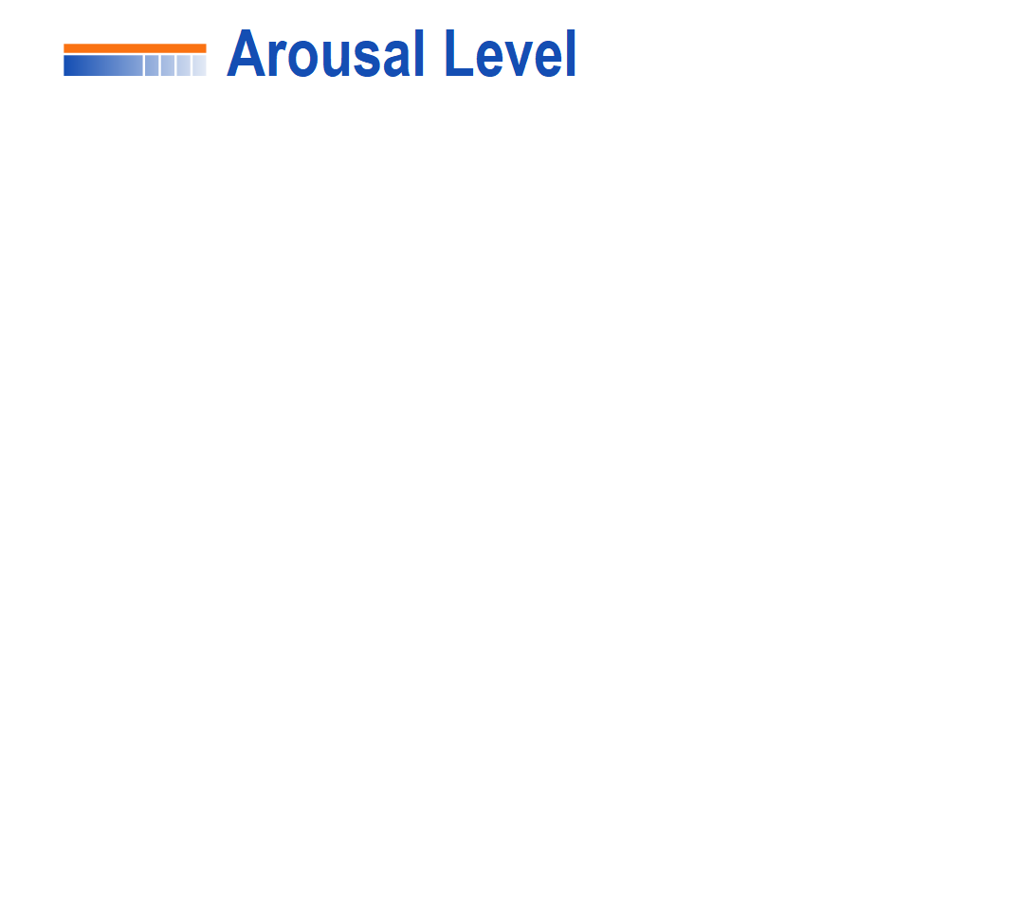
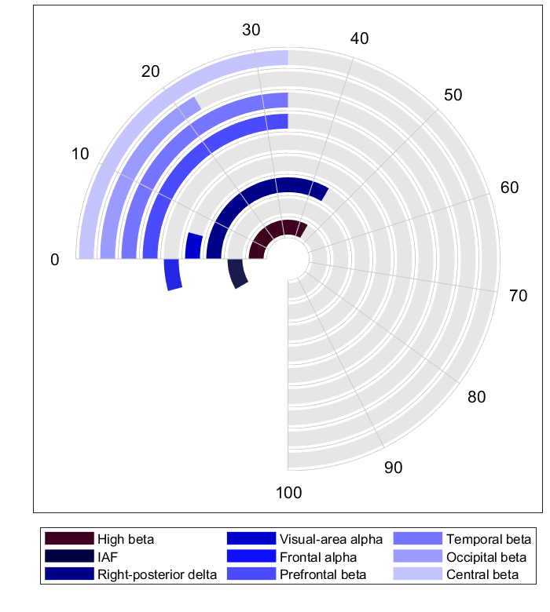

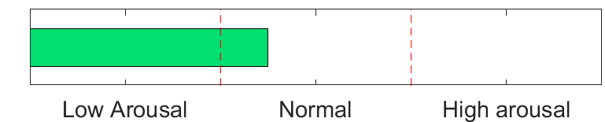

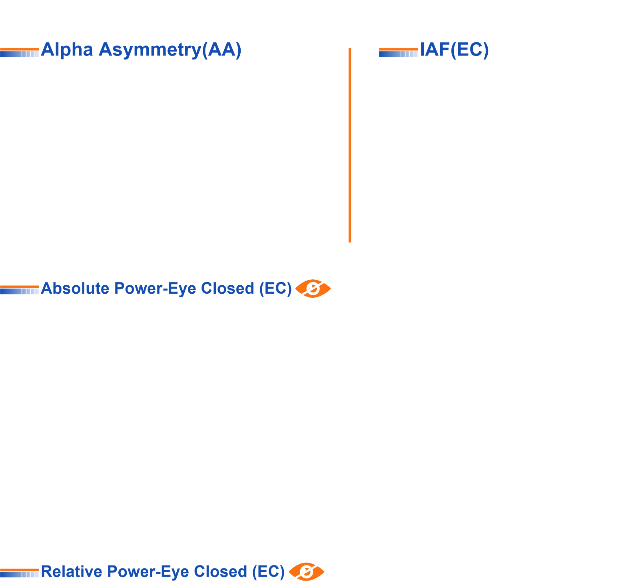

Eye Close IAF= 10.38

